Rotation Around an External Axis

Definition
# Source: AI Source: Provided by: [Data Path: Persons Table -> ID Column: 1, Name_En Column: Motasem Essam] -> From: [ChatGPT] on [7/25/2026]
Rotation Around an External Axis is a method of generating a solid of revolution by rotating a two-dimensional plane region through an angle, usually ${360}^{∘}$, around a straight line that lies in the same plane as the region but does not intersect its interior.
The axis of revolution is positioned outside the generating region. Consequently, the generated solid generally contains a central opening or hollow region, depending on the shape and position of the generating region.
The rotation produces a three-dimensional solid whose shape depends on:
- The geometric shape of the generating region.
- The perpendicular distance between the generating region and the axis.
- The dimensions of the generating region.
- The angle of revolution.
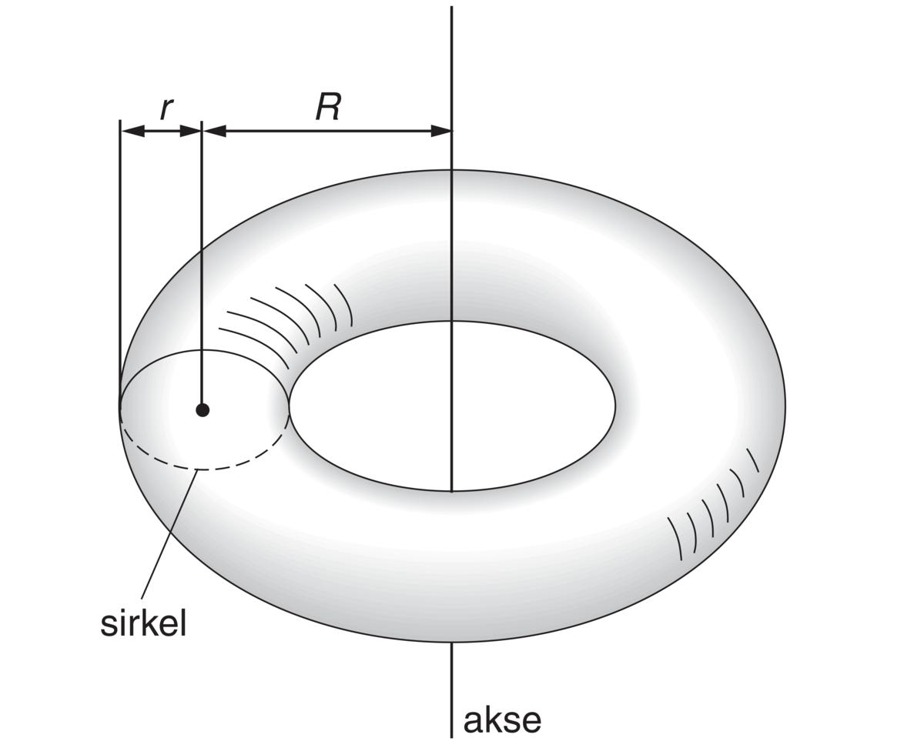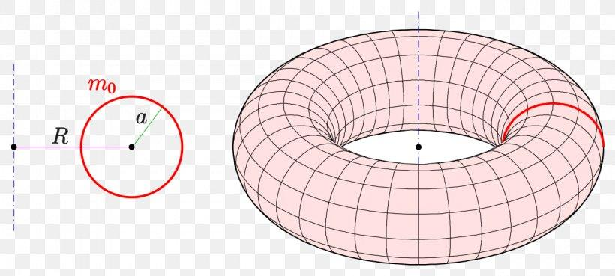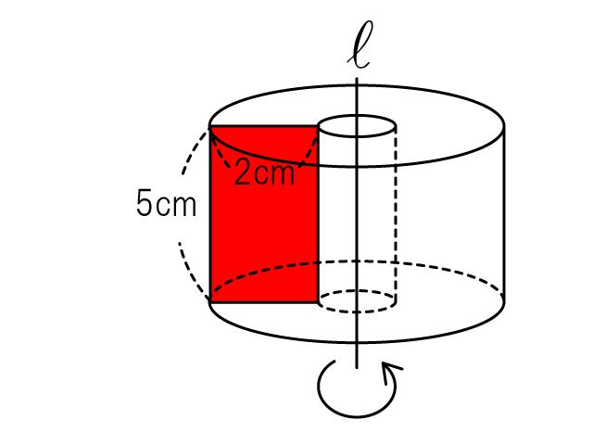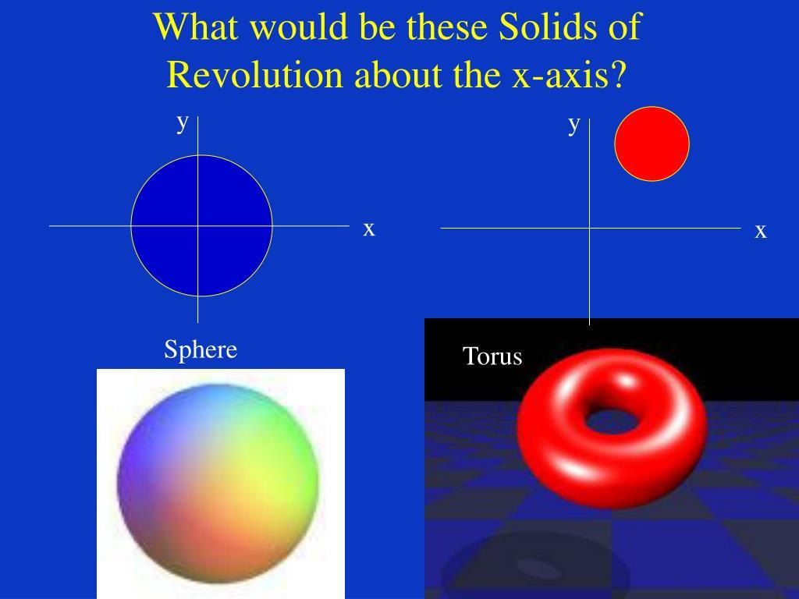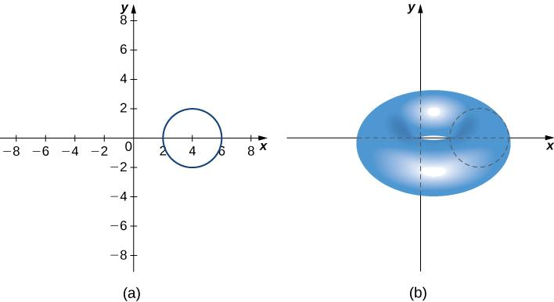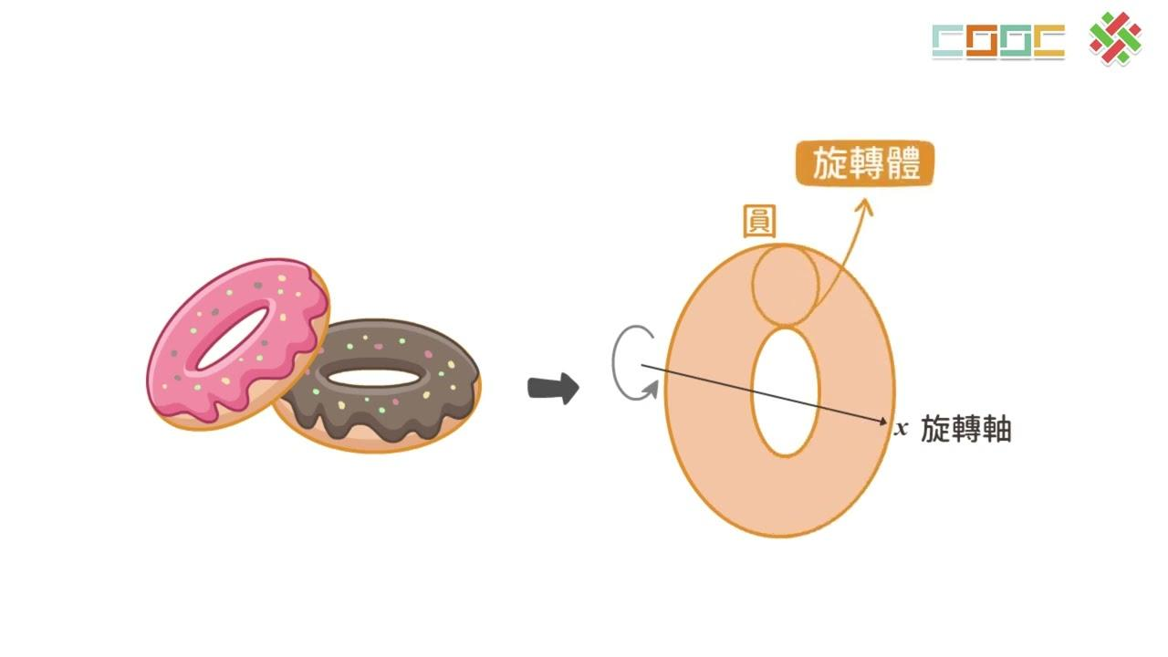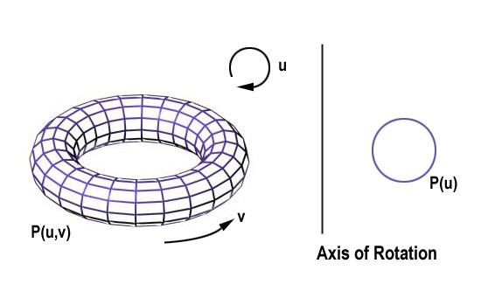

Geometric Structure
# Source: AI Source: Provided by: [Data Path: Persons Table -> ID Column: 1, Name_En Column: Motasem Essam] -> From: [ChatGPT] on [7/25/2026]
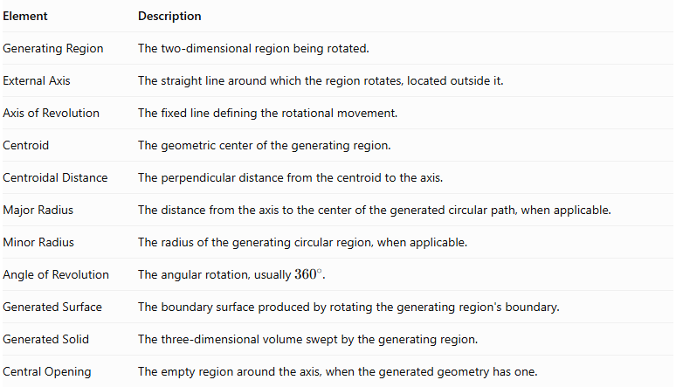
Element | Description
Generating Region | The two-dimensional region being rotated.
External Axis | The straight line around which the region rotates, located outside it.
Axis of Revolution | The fixed line defining the rotational movement.
Centroid | The geometric center of the generating region.
Centroidal Distance | The perpendicular distance from the centroid to the axis.
Major Radius | The distance from the axis to the center of the generated circular path, when applicable.
Minor Radius | The radius of the generating circular region, when applicable.
Angle of Revolution | The angular rotation, usually ${360}^{∘}$.
Generated Surface | The boundary surface produced by rotating the generating region's boundary.
Generated Solid | The three-dimensional volume swept by the generating region.
Central Opening | The empty region around the axis, when the generated geometry has one.

Main Geometric Characteristics
# Source: AI Source: Provided by: [Data Path: Persons Table -> ID Column: 1, Name_En Column: Motasem Essam] -> From: [ChatGPT] on [7/25/2026]
- The axis is outside the generating region.
- The generating region revolves around the external axis.
- The generated solid may contain a central opening.
- Circular paths are formed by points at a fixed perpendicular distance from the axis.
- The generated solid generally has rotational symmetry around the axis.
- The solid's volume depends on the area of the generating region and its distance from the axis.
- The generated geometry may be a torus, hollow cylinder, or another rotational solid.

Types of Rotation Around an External Axis
# Source: AI Source: Provided by: [Data Path: Persons Table -> ID Column: 1, Name_En Column: Motasem Essam] -> From: [ChatGPT] on [7/25/2026]
Rotation around an external axis can be classified according to the geometric shape of the generating region.

Rotation of a Circular Region Around an External Axis
# Source: AI Source: Provided by: [Data Path: Persons Table -> ID Column: 1, Name_En Column: Motasem Essam] -> From: [ChatGPT] on [7/25/2026]
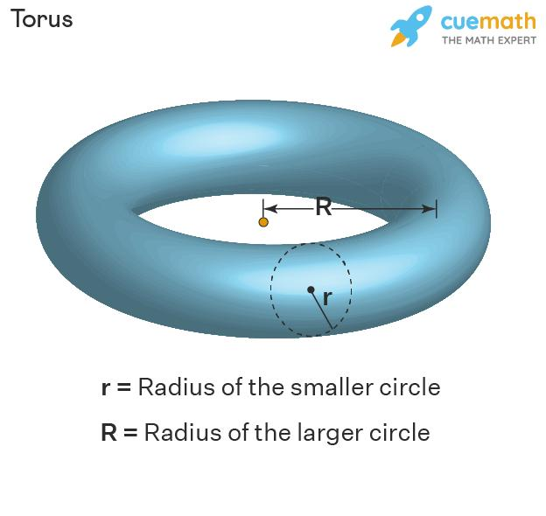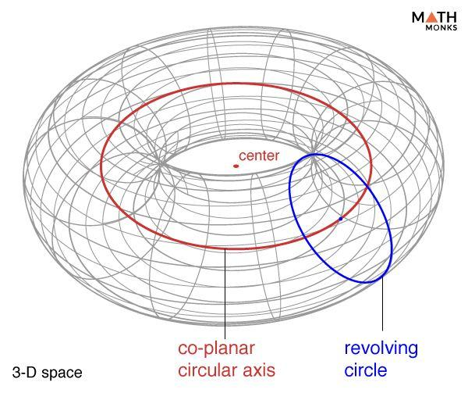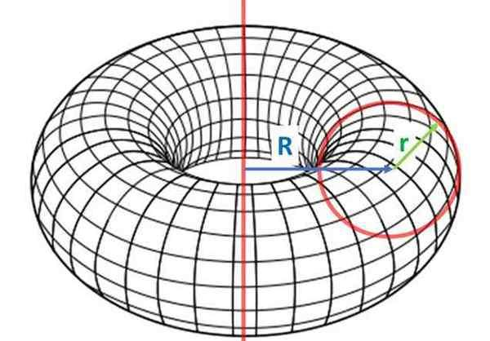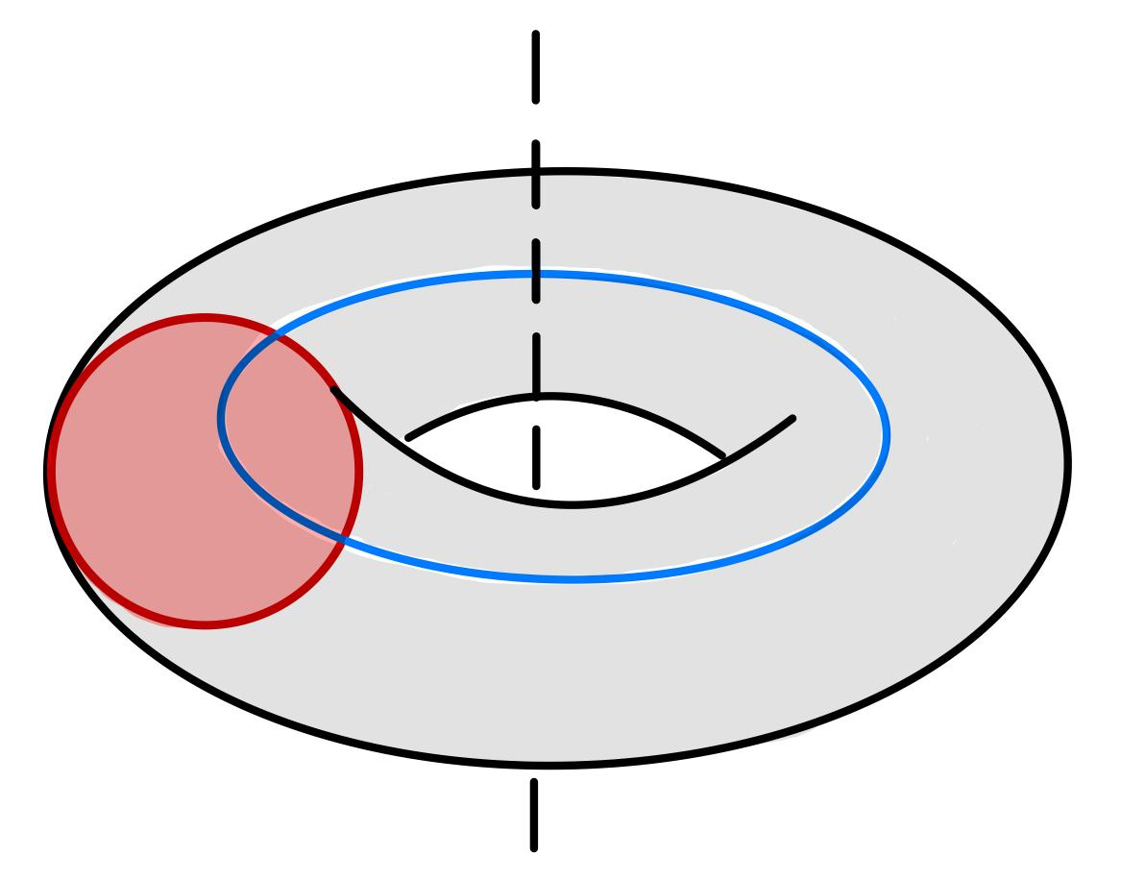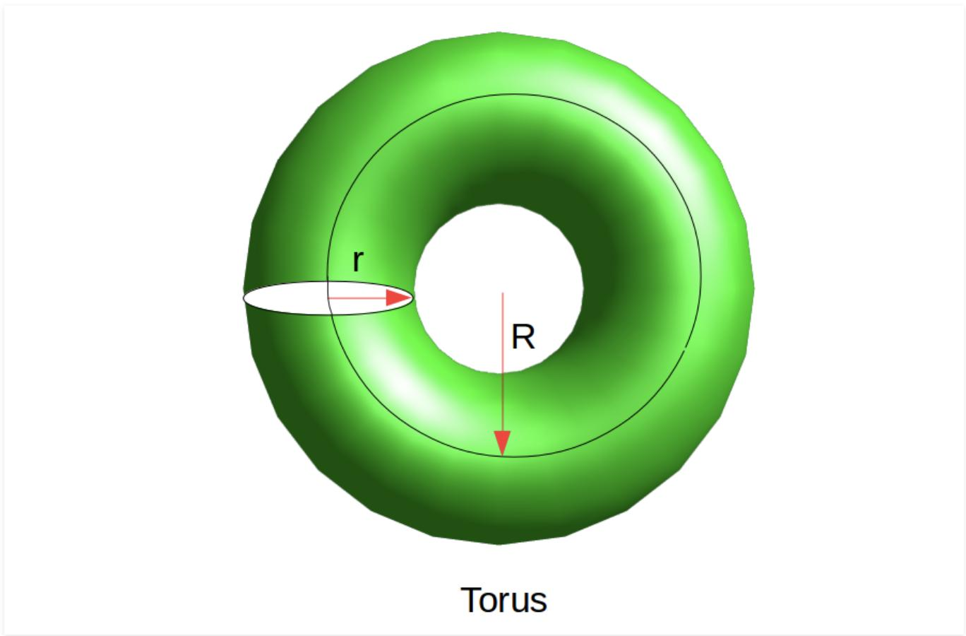
A circular region rotates around an external axis in its plane that does not intersect the circle.
Generated Solid: Ring Torus, when the axis is outside the circular disk and does not intersect it.
Let:
- $R$ = distance between the axis and the center of the circle.
- $r$ = radius of the circle.
For a ring torus, $R>r$.
Volume:
$$V=2π^{2}{Rr}^{2}$$
Surface Area:
$$S=4π^{2}Rr$$

Rotation of a Rectangular Region Around an External Axis
# Source: AI Source: Provided by: [Data Path: Persons Table -> ID Column: 1, Name_En Column: Motasem Essam] -> From: [ChatGPT] on [7/25/2026]
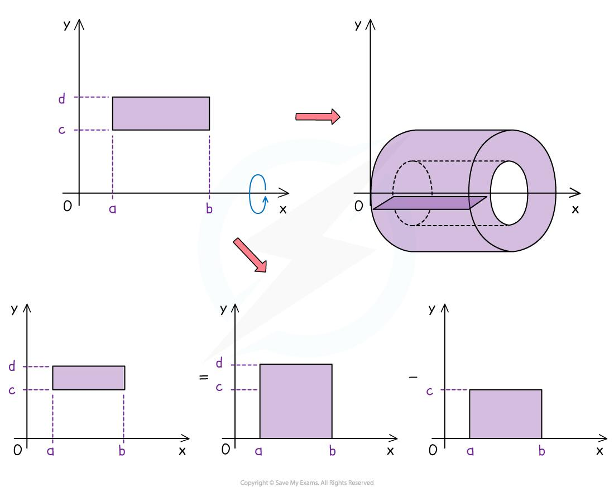
A rectangular region rotates around an external axis parallel to one of its sides.
Generated Solid: Hollow Cylindrical Solid.
If:
- $R$ = distance from the axis to the farther edge of the rectangle.
- $r$ = distance from the axis to the nearer edge.
- $h$ = rectangle height.
Volume:
$$V=πh(R^{2}-r^{2})$$
Curved Surface Area:
$$S_{L}=2πh(R+r)$$
Total Surface Area, including both annular ends:
$$S_{T}=2πh(R+r)+2π(R^{2}-r^{2})$$

Rotation of a Triangular Region Around an External Axis
# Source: AI Source: Provided by: [Data Path: Persons Table -> ID Column: 1, Name_En Column: Motasem Essam] -> From: [ChatGPT] on [7/25/2026]
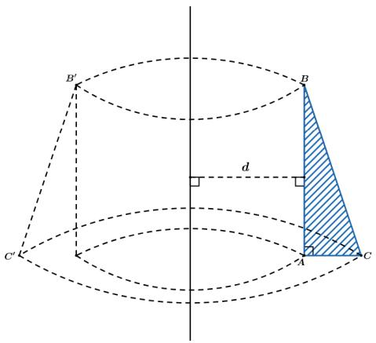
A triangular region rotates around an external axis in the same plane.
Depending on the triangle's position and orientation, the generated solid may have a conical or frustum-like boundary, potentially with an opening.
The exact resulting solid depends on the triangle's vertices and the axis position.

Rotation of an Elliptical Region Around an External Axis
# Source: AI Source: Provided by: [Data Path: Persons Table -> ID Column: 1, Name_En Column: Motasem Essam] -> From: [ChatGPT] on [7/25/2026]
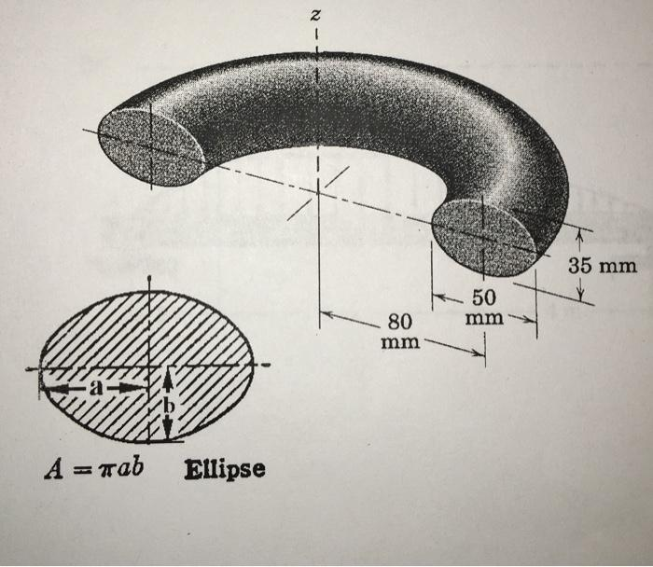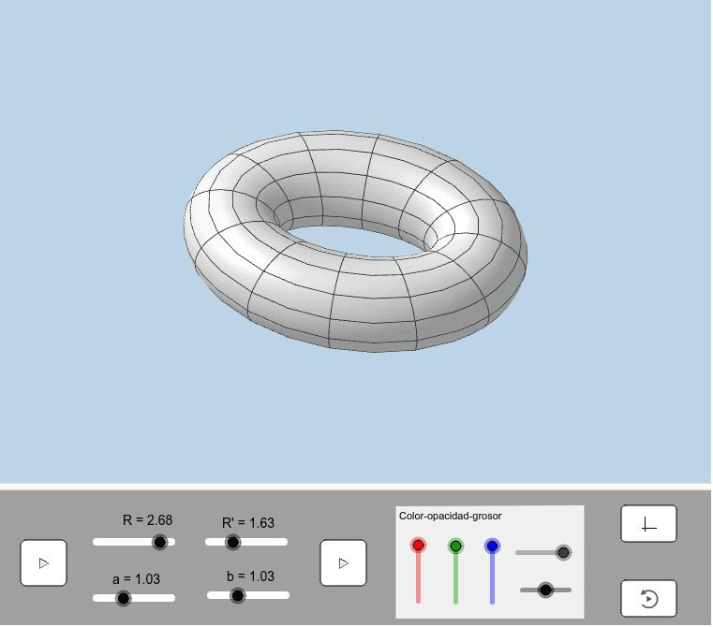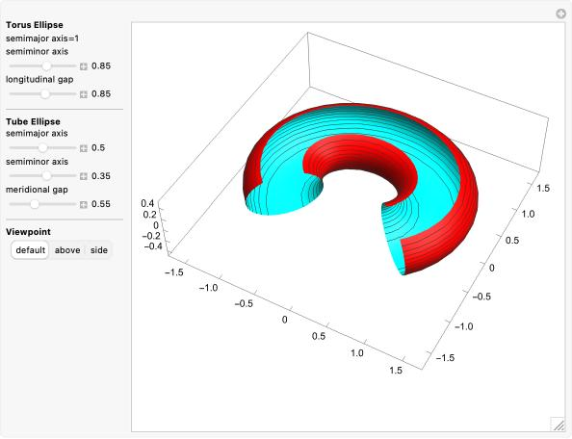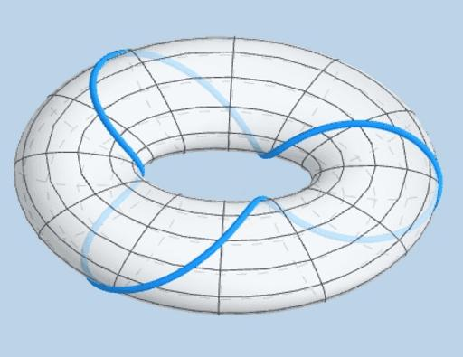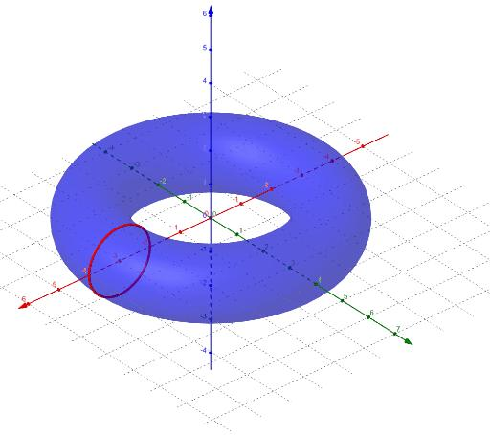
An elliptical region rotates around an external axis in its plane that does not intersect the region.
Generated Solid: Elliptical Torus (also called a toroidal solid with an elliptical cross-section).
The resulting solid has an elliptical cross-section revolving around the axis.

Rotation of an Irregular Region Around an External Axis
# Source: AI Source: Provided by: [Data Path: Persons Table -> ID Column: 1, Name_En Column: Motasem Essam] -> From: [ChatGPT] on [7/25/2026]
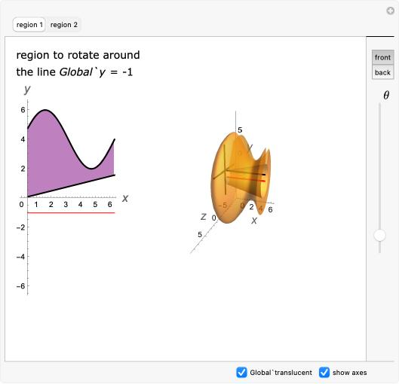
An irregular plane region rotates around an external axis.
The resulting solid has a non-uniform rotational profile determined by the shape of the generating region and its distance from the axis.
Its cross-sections perpendicular to the axis are generally circular annular regions or disks, depending on the geometry.

Mathematical Representation

Pappus's Centroid Theorem for Volume
# Source: AI Source: Provided by: [Data Path: Persons Table -> ID Column: 1, Name_En Column: Motasem Essam] -> From: [ChatGPT] on [7/25/2026]
The volume of a solid generated by rotating a plane region around an external axis can be calculated using the second theorem of Pappus.
$$\boxed{V=2πdA}$$
Where:
- $V$ = volume of the generated solid.
- $A$ = area of the generating region.
- $d$ = perpendicular distance from the centroid of the generating region to the axis of revolution.
The centroid travels a circular distance of:
$$D=2πd$$
Therefore:
$$V=A×D$$
This theorem applies when the axis does not intersect the generating region and the rotation does not produce overlapping coverage.

Pappus's Centroid Theorem for Surface Area
# Source: AI Source: Provided by: [Data Path: Persons Table -> ID Column: 1, Name_En Column: Motasem Essam] -> From: [ChatGPT] on [7/25/2026]
For a generating curve rotated around an external axis, the surface area is:
$$\boxed{S=2πdL}$$
Where:
- $S$ = generated surface area.
- $L$ = length of the generating curve.
- $d$ = perpendicular distance from the curve's centroid to the axis.

Washer Method
# Source: AI Source: Provided by: [Data Path: Persons Table -> ID Column: 1, Name_En Column: Motasem Essam] -> From: [ChatGPT] on [7/25/2026]
When a plane region is rotated around an external axis, the cross-sections perpendicular to the axis can form washers.
$$\boxed{V=π\int_{a}^{b}{\left[R(x)^{2}-r(x)^{2}\right]dx}}$$
Where:
- $R(x)$ = outer radius.
- $r(x)$ = inner radius.
- $a,b$ = integration limits.
The washer method is particularly useful when the external axis is parallel to the coordinate axis.

Mathematical Properties
# Source: AI Source: Provided by: [Data Path: Persons Table -> ID Column: 1, Name_En Column: Motasem Essam] -> From: [ChatGPT] on [7/25/2026]
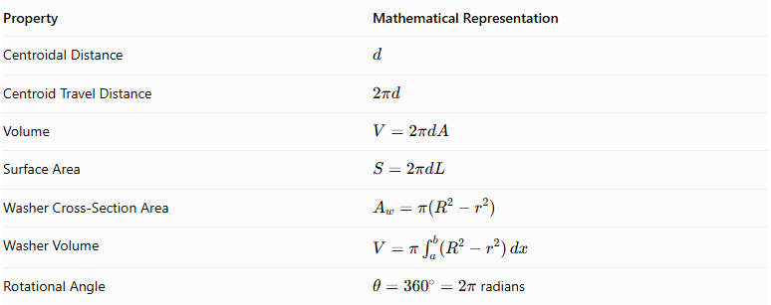
Property | Mathematical Representation
Centroidal Distance | $$d$$
Centroid Travel Distance | $$2πd$$
Volume | $$V=2πdA$$
Surface Area | $$S=2πdL$$
Washer Cross-Section Area | $$A_{w}=π(R^{2}-r^{2})$$
Washer Volume | $$V=π\int_{a}^{b}{(R^{2}-r^{2})} dx$$
Rotational Angle | $θ={360}^{∘}=2π$ radians

Geometric Applications
# Source: AI Source: Provided by: [Data Path: Persons Table -> ID Column: 1, Name_En Column: Motasem Essam] -> From: [ChatGPT] on [7/25/2026]
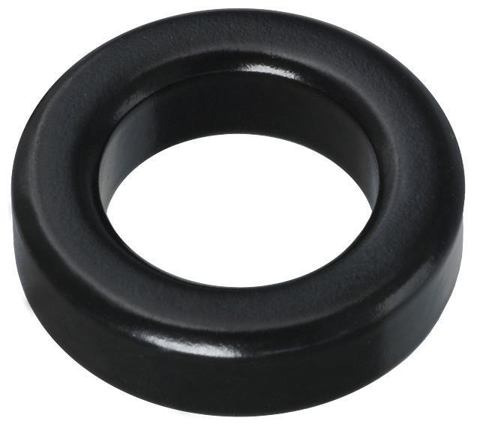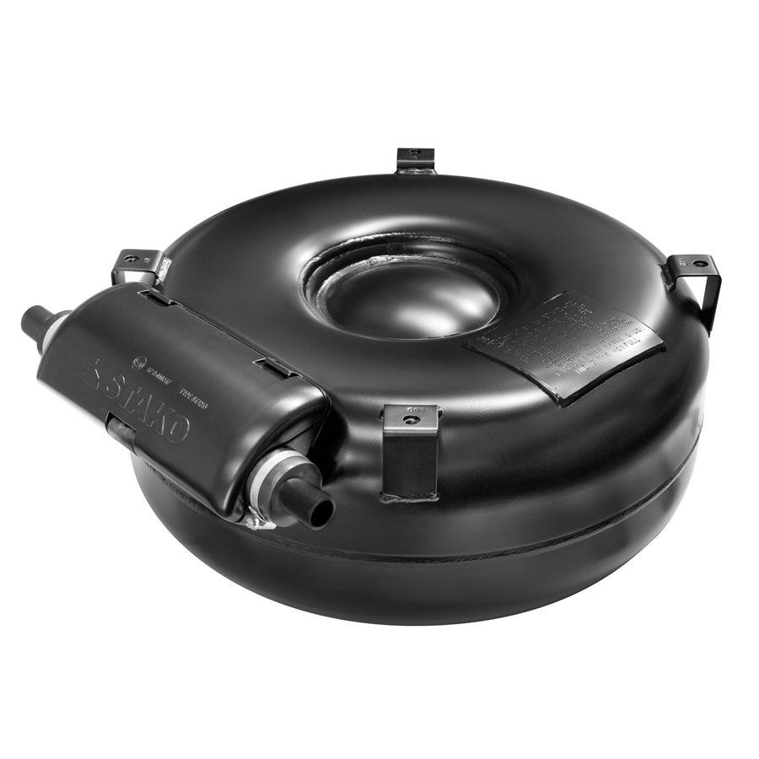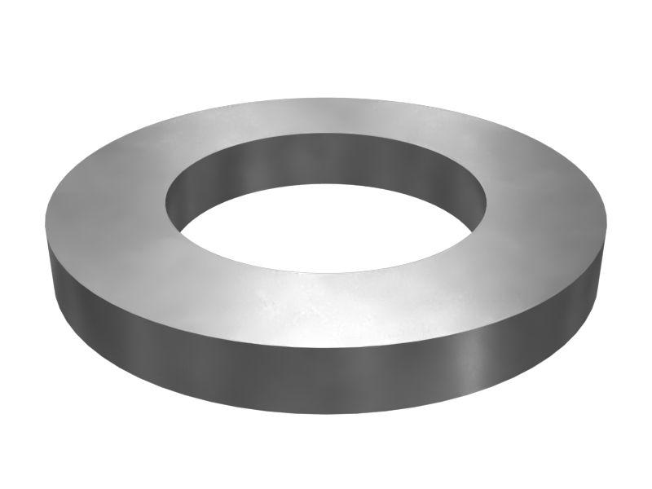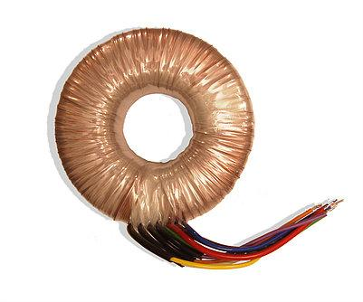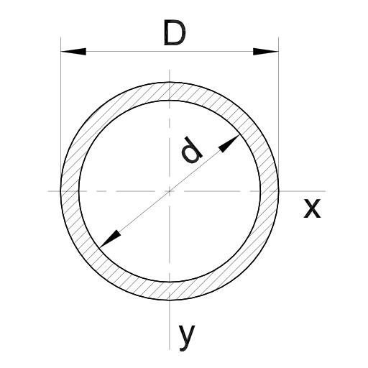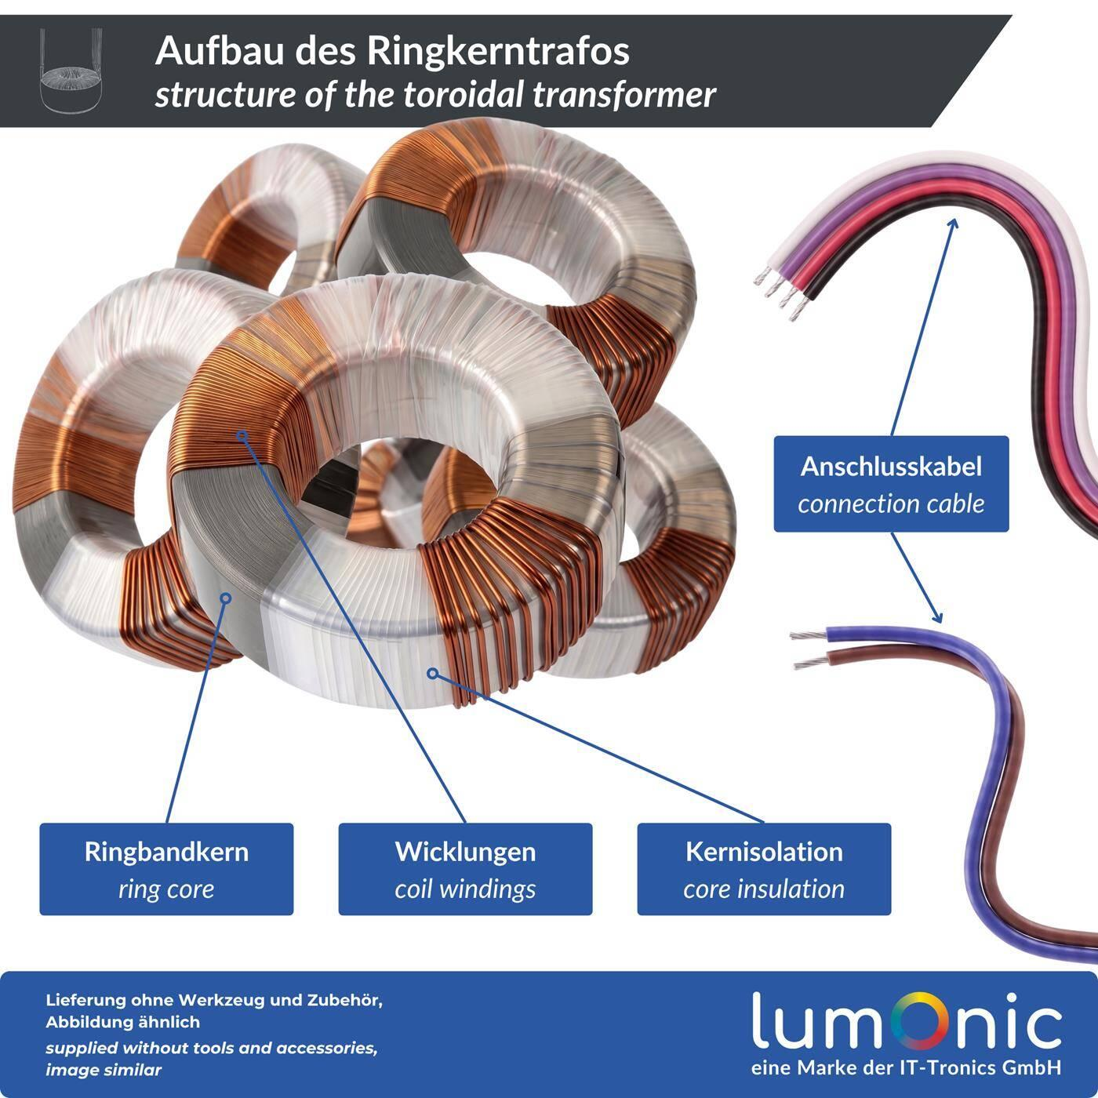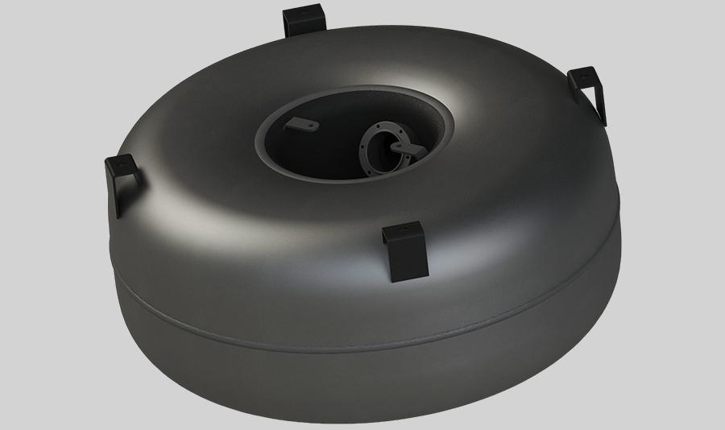
- Mechanical Engineering: Manufacturing toroidal and hollow rotational components.
- Electrical Engineering: Toroidal transformer and inductor cores.
- Industrial Design: Producing hollow rotational components and ring-shaped structures.
- Architecture: Designing circular and toroidal structures.
- Fluid Systems: Designing pipes, ducts, and curved hollow conduits.

Comparison with Other Axis Positions
# Source: AI Source: Provided by: [Data Path: Persons Table -> ID Column: 1, Name_En Column: Motasem Essam] -> From: [ChatGPT] on [7/25/2026]
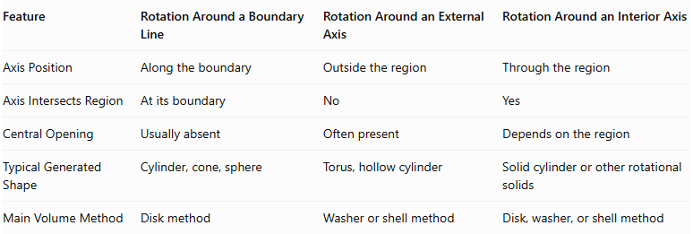
Feature | Rotation Around a Boundary Line | Rotation Around an External Axis | Rotation Around an Interior Axis
Axis Position | Along the boundary | Outside the region | Through the region
Axis Intersects Region | At its boundary | No | Yes
Central Opening | Usually absent | Often present | Depends on the region
Typical Generated Shape | Cylinder, cone, sphere | Torus, hollow cylinder | Solid cylinder or other rotational solids
Main Volume Method | Disk method | Washer or shell method | Disk, washer, or shell method

Main Classification
# Source: AI Source: Provided by: [Data Path: Persons Table -> ID Column: 1, Name_En Column: Motasem Essam] -> From: [ChatGPT] on [7/25/2026]
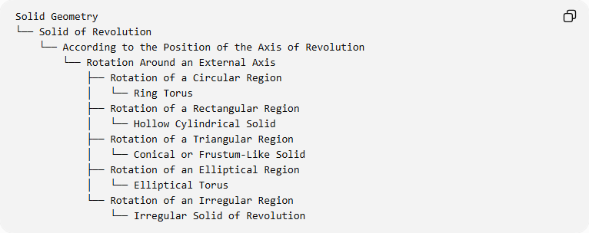
Solid Geometry
└── Solid of Revolution
└── According to the Position of the Axis of Revolution
└── Rotation Around an External Axis
├── Rotation of a Circular Region
│ └── Ring Torus
├── Rotation of a Rectangular Region
│ └── Hollow Cylindrical Solid
├── Rotation of a Triangular Region
│ └── Conical or Frustum-Like Solid
├── Rotation of an Elliptical Region
│ └── Elliptical Torus
└── Rotation of an Irregular Region
└── Irregular Solid of Revolution

Key Points
# Source: AI Source: Provided by: [Data Path: Persons Table -> ID Column: 1, Name_En Column: Motasem Essam] -> From: [ChatGPT] on [7/25/2026]
- Rotation around an external axis occurs when the axis lies outside the generating region.
- The generating region does not intersect the axis.
- The generated solid may have a central opening.
- A circular region rotated around an external coplanar axis produces a torus.
- A rectangular region rotated around an external parallel axis produces a hollow cylindrical solid.
- Pappus's centroid theorem provides a convenient method for calculating volume and surface area.
- The washer method is useful for determining the volume of solids with hollow cross-sections.

Conclusion
# Source: AI Source: Provided by: [Data Path: Persons Table -> ID Column: 1, Name_En Column: Motasem Essam] -> From: [ChatGPT] on [7/25/2026]
Rotation Around an External Axis is an important classification of solids of revolution based on the position of the axis relative to the generating region. By rotating a plane region around an axis that does not intersect it, different three-dimensional solids can be generated, including toroidal solids, hollow cylindrical solids, and other hollow or ring-shaped geometries.
The resulting solid depends on the shape and dimensions of the generating region and its distance from the external axis. Pappus's centroid theorem and the washer method provide important mathematical tools for studying these solids.

